Topic: Preparation for Skills for Life ESOL entry 1 exams using the topic of health and safety at work
Level: Entry level 1 / Scottish Access 2 / CEFR A1
Time: 150 minutes plus extensions. You may wish to use this over 2 sessions

Aims:
- To introduce some basic health and safety signs and talk about health and safety at work.
- To familiarise learners with some aspects of reading, writing, speaking and listening exams.

Objectives
Learners will be able to:
- recognise some basic health and safety signs in a work and prison context
- talk about health and safety using can’t and must not and can
- talk for one to two or more minutes about their own experience of health and safety and work
- recognise two text types (poster, advert) and answer some questions
- write a short email about themself

Introduction
This lesson gives practice in elements of the Skills for Life ESOL exam papers. In each reading paper candidates are required to identify signs, recognise basic text types and purpose and identify capital letters. These aspects are practised in activities 1, 4 and 7. In the speaking and listening exam, candidates should speak uninterrupted using a set of prompts. Similar practice is given in activities 3 and 4.

You will need:
- Resource 1: to display to learners (or large copy) and 1 per learner
- Resource 2: 1 set cut up per pair
- Resource 3: 1 per learner
- dice
- Resource 4: to display to learners and 1 per learner
- Resource 5: to display to learners
- Resource 5: to display to learners and 1 per learner
- Audio LP_ExamsE1_H&S

Procedure
Warmer (10 minutes)
- Elicit different places where learners currently work in the prison or have worked previously. Write them on the board.
- Display resource 1 or hand out signs to pairs of learners.
- Ask them to discuss which signs learners see or have seen in their place of work.
- Elicit feedback.

Activity 1 – Vocabulary: health and safety signs (20 minutes)
- Put learners into pairs. Focus their attention on resource 1. Ask them to discuss possible meanings of the signs.
- Elicit feedback from the class by nominating learners in turn to identify a sign. Before confirming / correcting, ask another person if he or she agrees. If both are wrong, ask a third before giving the correct answer.
- Hand out a set of resource 2 word cards to each pair. Clarify meanings of possible unknown words with concept check questions – entry, exit, slip, hazard, first aid, emergency e.g. ‘Does entry mean go in or go out? Is a hazard something safe or something dangerous?’
- Ask them to try and match the meanings to the pictures. Correct answers.
- Drill each of the phrases until confident.
- Ask learners to write up the answers onto resource 1.
Differentiation
- Support less confident learners with extra oral drilling or further practice matching resource 2 word cards with the pictures on resource 1 (folded in half to hide the words they have written next to them )
- Meanwhile, ask more confident learners to also fold resource 1 in half to show only the signs. In pairs, one learner should point to signs and their partner should identify them using the correct phrases and match the appropriate word card from resource 2. Swap roles.

Activity 2 – Vocabulary and listening: health and safety phrases (20 minutes)
- Look at each sign in resource 1. Elicit which colours can be seen and the shapes circle, rectangle and triangle.
- At the top of the board, draw two types of health and safety sign: a red circle with a line through on the left and a black triangle on the board on the right. Then draw a line down the middle to form two columns.
- Elicit the meanings: red circle = you must no t/ can’t do this and triangle = be careful/ warning.
- Explain prohibit = must not / can’t do and warn = be careful. Write these words above each sign.
- Ask for the opposite of danger / hazard (safe). Elicit the colour of safe signs (green) and check they understand that green also indicates first aid.
- Ask learners not to look at resource 1. In teams of two or more, ask learners to draw the sign or corresponding words from memory on a piece of paper in two separate columns.
- Ask them to write from memory which actions are prohibited (you must not do) and which you must be careful about. The winner is the team that remembers most under each heading (six in total).
- Next, on the board, under the circle write You must not and under the triangle write You can, but be careful. Clarify the meaning of each one.
- Look together at the first sign on resource 1. Elicit from the learners the correct first sentence – You must not smoke, as an example.
- For the remaining signs elicit the appropriate phrase to form a sentence and write on the board.
- Drill the phrases.
- Display resource 3 and elicit the workplaces shown in the 3 pictures.
- Hand out resource 3 and ask learners to listen to the three speakers talking about health and safety in the audio and to guess and write the number of the order they hear the place next to the picture (Task 1).
- Ask them to write the work place next to pictures.

Activity 3 – Talking about health and safety at work (20 minutes)
- Look at resource 3 together. For each picture text elicit the key phrases with must not and can, but be careful from the pictures.
- Elicit what the pictures represent e.g. the floor is wet and you can slip.
- Write this on the board and ask learners to write next to the picture.
- Now ask learners to listen and match the place to the safety signs you will see there (Task 2).
- Listen again and elicit reasons from the texts why people must be careful or not do something. Write up onto the board.
- Elicit more possible can’t and must not and can phrases with reasons from learners about their workplaces in the prison and the classroom/ education block.
- Write up on the board. Drill the phrases.
Activity 4 – Speaking: health and safety (10 minutes)
- Write numbers 1-6 on the board and next to each number write one of the places mentioned in the audio or by the learners e.g. classroom, chapel, garage.
- Pass the dice to a learner. He or she should roll the dice and talk about the place which corresponds to the number using the phrases about health and safety of that place from Activity 3.
Differentiation/ extension
- To allow for practice at learners’ levels, this activity could also be done in pairs/ small groups with one dice per pair. Group learners according to levels.

Activity 5 – Using prompts and notes to talk (20 minutes)
- Display resource 4 and focus on the speaking prompts. Read each one and check learners understand the instructions.
- Explain that this task is good practice for the speaking exam in which learners should speak uninterrupted without questions from the teacher using prompts.
- Point out the line which explains about making notes. Elicit what learners think that means: key words about what they want to say or a diagram, if writing is difficult.
- Choose a confident learner from the class as a model. Elicit the learner’s information and decide with the whole class what notes you could make. Write on the board. Make sure you keep this as you will need it for the next task.
- Using the prompts and the notes, give a model answer yourself or ask the learner to try. Ask another learner to time the activity. Explain that in the exam, it is necessary to talk for between 2-3 minutes.
- Put learners into groups to work with those of the same level. Ask the learners to make notes on resource 4 about their own situation to prepare to talk with a partner.
- Support, check the notes and deal with any issues. In pairs, ask learners to speak to their partner without stopping for 2 or 3 minutes following all the prompts and notes.
- Their partner should listen and check they covered each point and give feedback.
Differentiation
- Support lower level-learners in a small group, leaving stronger learners to work more independently or in pairs.
Activity 6 – Writing: write a message (20 minutes)
- Show resource 5 and elicit what it is. Tell learners they are going to write an email telling someone about the partner they have just spoken to.
- Ask learners to look at the notes you wrote on the board about the learner for Activity 5.
- Elicit some sentences from the notes about the learner.
- Elicit how to start and finish the email then ask learners to write about their partner, using their partner’s notes. Monitor and make a note of any common errors.
- When they finish they get them to work with their partner and correct together.
- Feedback any common errors.
Differentiation/ extension
- Create a writing frame for weaker learners.
- Use the email as a reading text.
Activity 7 – Reading health and safety texts (20 minutes)
- Display resource 5 and elicit the health and safety signs shown.
- Elicit what type of document each text is. If unknown, ask: ‘Which is a poster and which is an advert?
  - Similarities: not much text so easy to read and get information; different size fonts – some very large; may include pictures
  - Differences: adverts may have money; language to try to persuade you: poster = facts.
- Ask learners to read the texts and answer the questions individually.
- Correct and feedback how learners found the answers in these texts.
Differentiation
- Support less confident readers with the questions on the text.
- When more confident learners have finished, ask them to circle all the capital letters in the two texts.
Cooler (10 minutes)
- Play a game similar to Pictionary (as a team game on the board or in pairs on scrap paper)
- Show one of the word cards from resource 2 to a learner. He or she should try to recall and draw the corresponding sign on the board for others or their partner to guess.
- After that activity, write some of the workplaces mentioned in the opening warmer activity on the board. In pairs, ask learners to choose a different place each and tell their partner some of the health and safety considerations for each place.

Extension activities / Homework
- Look around the prison and note down 6 more prohibition and warning signs to bring to class to discuss.
- Use resource 1 cut up into picture and word cards. Ask learners to practise matching them in their cell and be prepared to be tested the following lesson.
- Look at other exam papers, pick out instructions and elicit from learners what they need to do.
- Follow up with a session on mandatory (blue) and safe / first aid (green) signs.

Answer key
Resource 1: 1. no smoking 2. first aid 3. danger 4. fire hazard 5. slip hazard – wet floor 6. do not drink 7. emergency exit 8. do not enter.

Activity 2: 1. You must not smoke. 3. You can have an accident. 4. You can have a fire. 5. You can slip. 6. You must not drink this. 8. You must not enter.

Resource 3
Task 1. a factory 2. a kitchen 3. a garage

Task 2
1. kitchen = you can slip; you must not smoke
2. garage = you can have an accident; you must not drink the water
3. factory = the machine can catch fire; you must leave by the emergency exit.

Resource 6
1.first aid kits 2. £9.99 3. www.firstaid.co.uk 4. an advert 5. Jon Pattison 6. 7362 7. kitchen 8. a poster

Transcripts
1. Factory
Be careful. The machines here are on 24 hours a day and get very hot. This machine can catch fire. The fire extinguisher is next to the door and the emergency exit is over there, on the right.

2. Kitchen
It’s very important for this area to be clean. You must not smoke in here. Go outside for that. Be careful. Sometimes the floor is wet and you can slip. Remember, please don’t run.

3. Garage
This is a noisy place. The machines can be dangerous so be careful. You can have an accident. You must not drink this water here – it’s only for washing the cars.

Resource 1 Health and safety signs

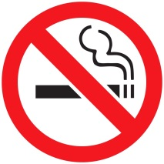
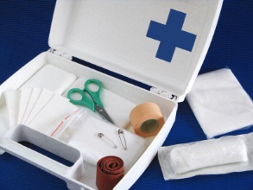

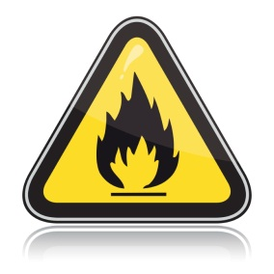
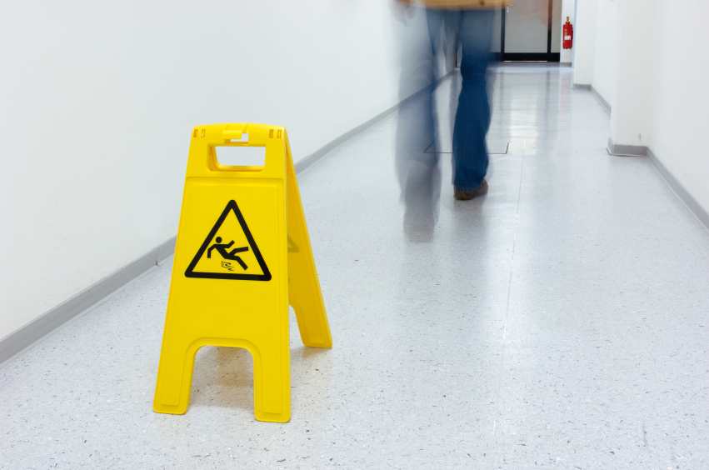
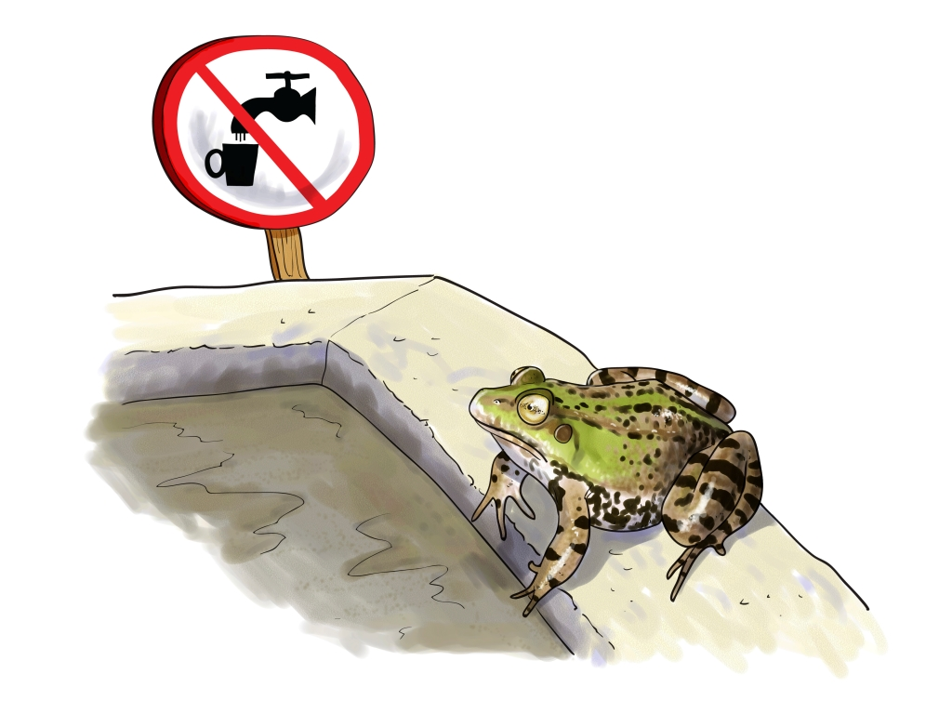
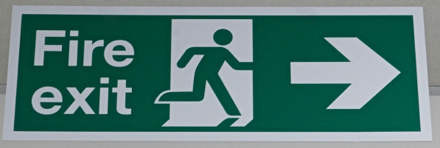


Resource 2 Word cards
No smoking
Emergency exit
Do not drink
Fire hazard
Slip hazard – wet floor
No entry
First aid
Danger

Resource 3 Listening and speaking

Task 1
 | 
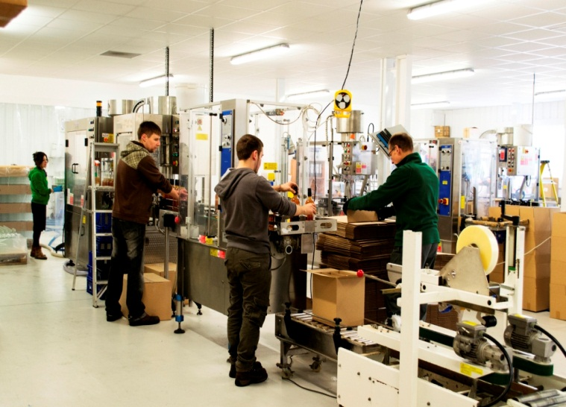

Task 2
 | 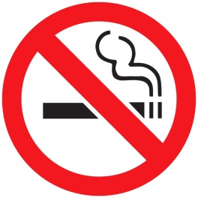 |  | 
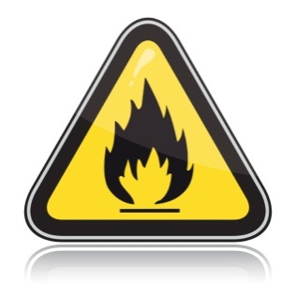 | 
Resource 4 Speaking prompts

Tell your partner  - your name  - where you work now (or want to work)  - what you do (or will do in your job) | Tell your partner about  - things you must not do in your workplace and why.  - accidents you can have in your workplace and why.
You can use this space to make notes.
………………………………………………………………………………………………………………………………………………………………………………………………………………………………………………………………………………………………………………………………………………………………………………………………………………………………………………………………………………………………….........................................................................................................................................................................................................................................................................................................................................................................................................................................................................................................................................................................................................................................................................................................................................................................................................................................................................................................................................................................................................................................................................................................................................................................................................................................................................................

Resource 5: Email

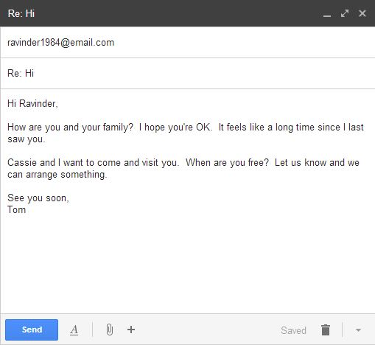

Resource 6: Health and safety texts

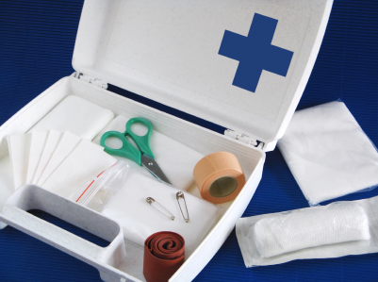 | Sale!  First aid kits half price  only £9.99  www.firstaid.co.uk
1. What is for sale?  2. How much is a first aid kit? |  | 3. What is the website address?  4.This text is  a poster    an advert 
 | First aid  Your first aider’s name is  Jon Pattison (kitchen)  Call Ext. 7362 in an emergency
5. The first aider’s name is …………......  6. His telephone number is …………..... |  | 7. Jon works in the …………………  8.This text is  a poster    an advert 

